Automatic Plant Watering System

Benjamin Clark

Tennessee Tech

ECE 1000

Dr. Bhattacharya, JC Williams

4/30/24

# Abstract

This project was intended to create an automatic watering system for hydro/geoponic farming, using Arduino sensors and a Raspberry Pi Pico running micropython.

*Keywords:* Hydroponics, automated plant watering, micropython

# Automatic Plant Watering System

The plant watering system was created to maintain a desired soil moisture level for ideal growing conditions. This may increase plant growth rates and reduce the risk of overwatering.

# Method

## Construction

The system was constructed from a Raspberry Pi Pico and accompanying breakout board. The sensors were connected to the board, and the pump was controlled by a relay. When the dial on the shown rotary encoder was turned, the indicator light would signal the adjustment of the desired moisture level. The switch was used to disable and enable the sensor, or manually activate the pump.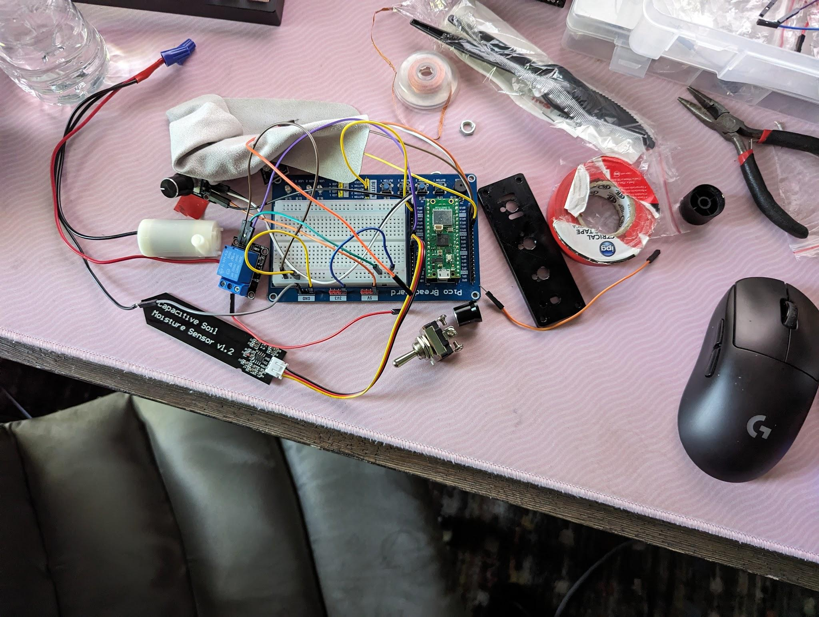

## 

The finished product was installed inside a plastic box, with holes drilled for the exterior components. It was powered by a USB-A to MicroUSB cable that could be connected to a laptop to run the micropython script.

## 

## Assessments and Measures

The finished system functioned as intended, producing positive results. Throughout the project, however, there were issues with the functionality of the moisture sensor. Due to its high sensitivity, the moisture level could sit right on the edge of the threshold in dry conditions. Rapid switching of the relay was often the result, which overloaded the board. This would cause the whole system to require a reset. Adding a delay to the script helped resolve the issue, but a less sensitive sensor or a script with a separate “reactivation” threshold may be needed in the future.

One discovery made during the testing of the device was that a slower pump speed was more desirable. Due to the delay between saturation of the overall soil and the arrival of water from the outlet of the pump, some portions of the soil could reach undesirable moisture levels before the sensor could detect a change. This may be remedied by placing the sensor closer to the outlet and allowing it to reactivate periodically as the moisture level averaged across the surrounding area.

The user interface was an area of success. The use of the switch, dial, and LED provided proper control over the entire system in an intuitive manner. Being able to switch the system off allowed for the repositioning of the sensor without unintentionally triggering the pump.

One last area where upgrades may be possible is with the Pico itself. Currently, the scripts must be run on an external computer. For permanent deployment (especially outdoors), a fully featured Raspberry Pi would be preferred, allowing the script to run uninterrupted without needing external systems.

# Results

Despite the flaws, the system worked very well. The moisture level was accurately monitored and consistently maintained. While further investigation into the long-term success and reliability would be ideal, everything functioned as intended in short-term testing.

# References

Admin, How To Electronics Team. “Interface Capacitive Soil Moisture Sensor V1.2 with Arduino.” *How To Electronics*, 20 Nov. 2022, [how2electronics.com/interface-capacitive-soil-moisture-sensor-arduino/](http://how2electronics.com/interface-capacitive-soil-moisture-sensor-arduino/).

George, Damien P. “MicroPython Documentation.” *Overview - MicroPython Latest Documentation*, [docs.micropython.org/en/latest/](http://docs.micropython.org/en/latest/).

Nedelkovski, Dejan. “How Rotary Encoder Works and How to Use It with Arduino.” *How To Mechatronics*, 17 Feb. 2022, [howtomechatronics.com/tutorials/arduino/rotary-encoder-works-use-arduino/](http://howtomechatronics.com/tutorials/arduino/rotary-encoder-works-use-arduino/).

Rasberry Pi Foundation. “Raspberry Pi Documentation - Paspberry Pi Pico and Pico W.” *Raspberry Pi*, [www.raspberrypi.com/documentation/microcontrollers/raspberry-pi-pico.html](http://www.raspberrypi.com/documentation/microcontrollers/raspberry-pi-pico.html).

# GitHub Repository

Clark, Benjamin, <https://github.com/benrc257/Plant-Watering-Project-ECE-1000>